The DOCUMENT OBJECT MODEL (DOM) 1:

INTRODUCTION:

1:PART A: INTRODUCTION TO THE DOCUMENT OBJECT MODEL (DOM): 2
2: What do we Mean by “Object”? 3
3: Why the Big Deal About Objects? 4
4: The DOM: 5
5: Useful DOM Resources: 7
6: PART B: OBJECT COLLECTIONS: 8
7:EXERCISE 1: Object Collections: 9
8: Referencing Objects by Tag, Name, and ID: 10
9: Object Collections and .getElementsByTagNames: An Example: 11
10:EXERCISE 2: Object Collections: 12
11:EXERCISE 3: Object Collections: 13
12: Object Properties and CSS Styles 1: Writing a Style: 14
13: EXERCISE 4: Writing a Style: 15
14: Object Properties and CSS Styles 2: Reading a Style: 16
15: EXERCISE 5: Reading a Style: 17
16: CSS Styles Using Class Objects: 18
17: EXERCISE 6: Class Objects: 19

1:PART A: INTRODUCTION TO THE DOCUMENT OBJECT MODEL (DOM):

JavaScript is an object-based language.

2: What do we Mean by “Object”?

- So far we have created functions, which are objects (customised objects).
- We have also used some built-in objects (variables), such as Math, Array, String, Number and Date objects.
- We can also create objects which can have properties that we also create. Have a look at SimpleObjectExample.htm, which allows you to modify the weight of a (virtual, not real!) dog.
- Some famous JavaScript Objects are JSON data (JavaScript Object Notation): more details later.
- Tags are also objects.
- There are also objects which refer to elements of the Web browser or Web document. These are called DOCUMENT OBJECTS. (e.g. document. or window.)

3: Why the Big Deal About Objects?

- Objects have properties. Consider a textbox called fName. We have the fName.length property (or fido.weight).
- Objects have methods (or associated JavaScript commands). e.g. the Math.floor() or document.write() methods.
- Objects can be manipulated using events: onblur onchange onselect onload. Comprehensive list at http://www.w3schools.com/tags/ref_eventattributes.asp.

4: The DOM:

Objects in Web documents and Web browsers need to be organised in a systematic manner. This is the purpose of the Document Object Model (DOM).

The next diagram organises webpage objects into a hierarchy called a document tree.

- An object can contain other objects. e.g. a document has a form, which has a selection list, which has options and optgroup.
- We are familiar with this idea of nesting: e.g. document.forms[0].prod: a form element in the first form in a webpage? This way of writing the pathway to a particular object is called dot syntax.
- Remember we sometimes write window.prompt or just prompt? If we leave out window. JavaScript assumes we are referring to the existing browser window.

(We could actually write window.document.forms[0].fname.value, but we normally don’t write window.)

Good reference: http://www.w3schools.com/jsref/default.asp: look at the window object, then look inside this for the document object; keep burrowing down!

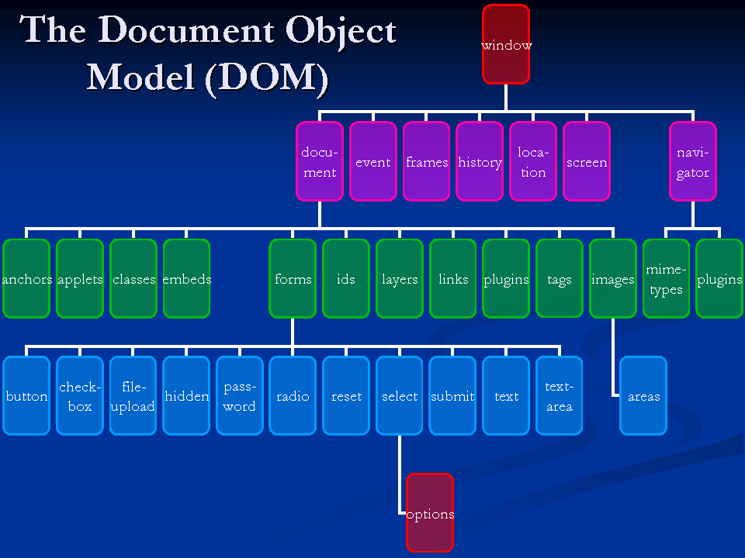

5: Useful DOM Resources:

An extremely useful weblink is at w3schools: http://www.w3schools.com/htmldom/default.asp.

Make sure you have Firebug added on to Firefox, and F12 for Developer Tools on 3 main browsers:
https://addons.mozilla.org/en-US/firefox/addon/6622/
https://addons.mozilla.org/en-US/firefox/addon/firebug/

Also F12 in Chrome. Console lets us see any JavaScript errors in our code. We can also set breakpoints.

6: PART B: OBJECT COLLECTIONS:
Objects of the same type are organised into arrays called object collections. e.g. document.forms. A particular array element is then written in the usual way i.e. document.forms[0] accesses the first form tag in the webpage.

Other object collection arrays include:
- document.forms[0].elements
- document.images
- document.links
Note that the object collections are always plural i.e. the last word.

We can use both forms[0] or the form name to refer to the form object.
Here’s an example of an image tag: <img src=”logo.jpg” id=”logoImg” />. Suppose this image is the 3rd image tag on the webpage as we read the html code from top to bottom. We can refer to this in 3 ways:
- document.images[2]
- document.images[“logoImg”]
- document.images.logoImg

We can always see how many objects are in an object collection by using the .length property. e.g. document.images.length.

We can use a loop to go through all of the objects in an object collection array. e.g. for document.images:
for ( var i=0 ; i<document.images.length ; i++ ) {
JavaScript code ...
}

We will do this later, when we create drop-down menus.

7:EXERCISE 1: Object Collections:

Add the following JavaScript code to the webpage ObjectCollections~IMAGES.htm, which is in the folder called “EXERCISE 1~ObjectCollections~Images”:

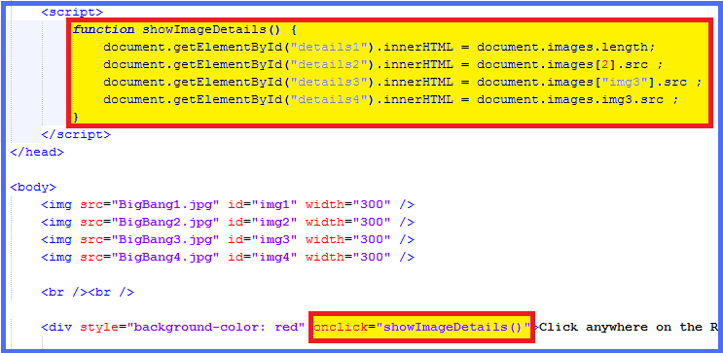

Run the webpage, does it work as it should?

8: Referencing Objects by Tag, Name, and ID:

We have already met document.getElementById( “fName” ). As each ID is unique, there is no object collection array involved.

The code var allElements = document.getElementsByTagName( “*” ) creates an array of ALL tags in the webpage.

To create an array storing information about all <p> tags you would use something like:
var allParagraphs = document.getElementsByTagName( “p” ).
The first <p> tag would then be referenced by allParagraphs[0].

To create an array storing information about all tags whose name is “postageOption”, (e.g. a set of radio buttons), you would use:
var allPost = document.getElementsByName( “postageOption” ).

9: Object Collections and .getElementsByTagNames: An Example:

Have a look at the webpage inside the folder called “EXERCISE 2~DOM example”. Essentially, by collecting the images <img /> and hyperlinks <a></a>, we can then display them elsewhere on the webpage.

- This may be particularly useful if we have links in a column to the left of the page but also want the same links elsewhere on the webpage.
- When we have to update the links on such a page, we need only update once: on the left of the webpage.

10:EXERCISE 2: Object Collections:

Add an extra link to the left of the above webpage, and refresh the webpage:
you should see the extra link also appearing at the bottom of the webpage.

11:EXERCISE 3: Object Collections:

Create a webpage (use HTML5 template) called DOMexercise3.htm with:
- two <h1> tags containing text, and
- a <div> containing no text.
- Write a JavaScript function that:
  - Collects all of the <h1> tags and puts them into an array;
  - Concatenates the contents of the two <h1> tags, separated by the text “JOINED WITH”;
  - Puts this text into the <div> tag.
  - Changes the background colour of this <div> to “chartreuse”.

12: Object Properties and CSS Styles 1: Writing a Style:

- Suppose your webpage has 4 <h1> tags, and you want to change the font-size to 24 pixels for the first <h1> only. You would use
- document.getElementsByTagName( “h1” )[0].style.fontSize = “24px”;

13: EXERCISE 4: Writing a Style:

Add the following code to the webpage called WritingAStyle~using getElementsByTagName.htm, which is in the “EXERCISE 4~Writing a Style” folder in the resources.
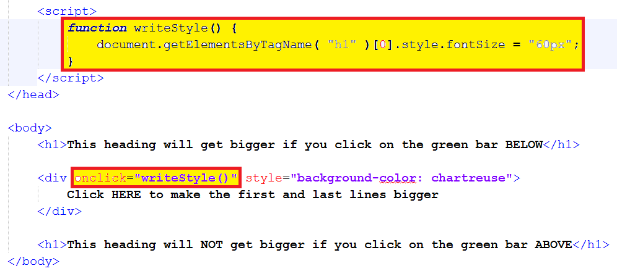

Run the webpage, does it work as it should?

14: Object Properties and CSS Styles 2: Reading a Style:

- Suppose you wanted to get a particular style value from some webpage object (which has an id=”imgBox” and style=”height: 300px”) and put it into a variable (say, heightString). Here’s how you would do it:
- heightString = document.getElementById( “imgBox” ).style.height;
- heightString would have the value of “300px” (can’t be used for calculations).
- Now, suppose you had heightNumber = parseInt(document.getElementById( “imgBox” ).style.height);
- heightNumber would have a value of 300 (can be used for calculations).

15: EXERCISE 5: Reading a Style:

Add the following code to the webpage called ReadingAStyle~Calculation.htm, which is in the “EXERCISE 5~Reading a Style” folder in the resources.

Notice the <script> tag is after the webpage contents. JavaScript code is often placed here as the content can load before the JavaScript code. In the case below the webpage should load before the JavaScript code as the code can only be run after div3 has been loaded.

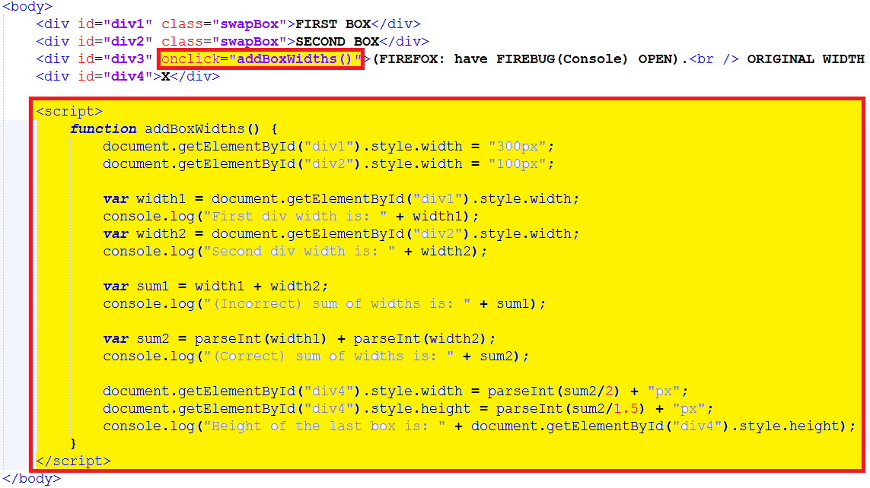

Run the webpage, does it work as it should?

16: CSS Styles Using Class Objects:

Suppose we have an object whose id=”flashyHeading”, and we want to change its colour to red. We can do this in 2 ways:
- As already seen: document.getElementById( “flashyHeading” ).style.color = “red”;.
- We could define a class style (e.g. .redText {color: red}), and then change the colour using document.getElementById( “flashyHeading” ).className = “redText”;. This is an easier approach because we can amend that style later in the stylesheet rather than in the JavaScript code.

17: EXERCISE 6: Class Objects:

Add the following code to the webpage called ChangingClassObjects.htm, which is in the “EXERCISE 6~Changing Class Objects” folder in the resources.

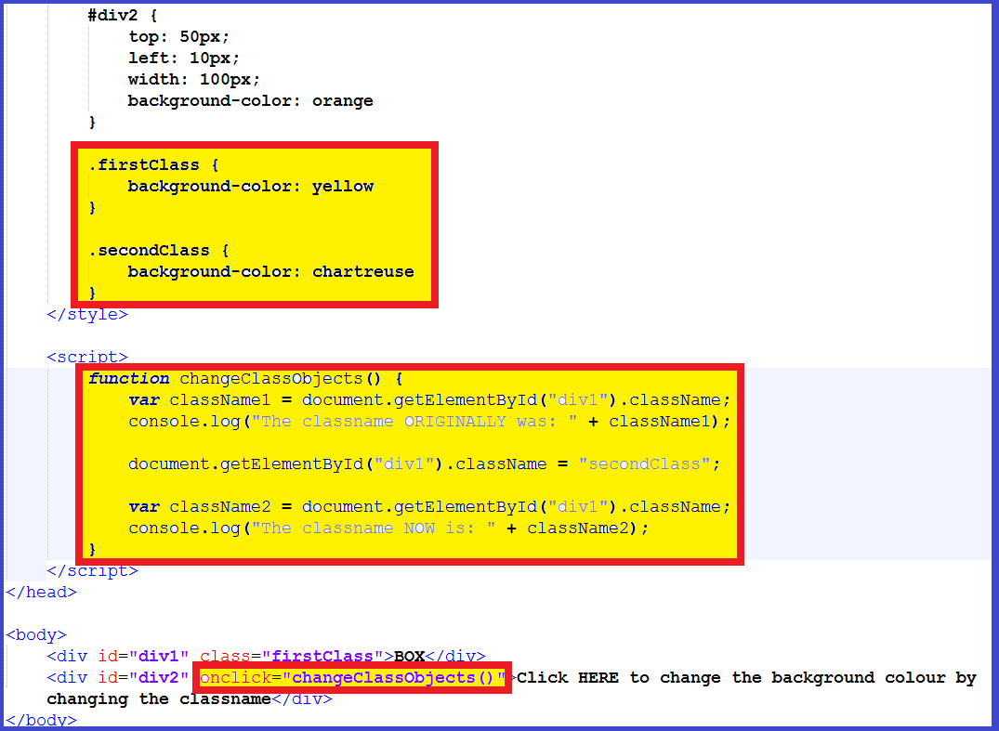

Run the webpage, does it work as it should?

